Connecting the Create to a network:

1. Put robot on dock to turn it on.
   1. Wait for it to make a noise chirp/melody to signify its fully turned on
2. Press the 2 side buttons until the LED ring turns blue, it should make a different chirp sound soon after
   1. A person's hand pressing a button on a circular object

      Description automatically generated
3. Connect to the robots network, it should have a name like ‘Create3_XXXX’
   1. Once connected, it should make a chirp sound
4. Open a browser and go to ‘192.168.10.1’
   1. After a moment you should get a page like this:
   2. 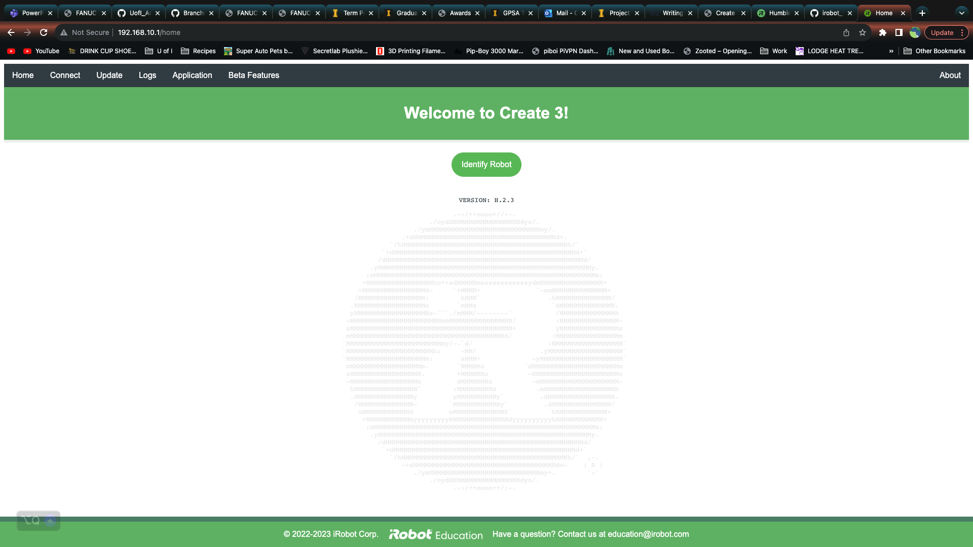
5. Click on the Update tab
6. Choose the firmware file I attached in the email, ‘Create3-H.2.3.swu’
   1. Once its attached, click ‘Upload file and update’
   2. This process will take about 5 minutes
7. Once its updated, verify you’re still connected to the robot network and go back to ‘192.168.10.1’ (or if you’re still on the webpage, click on the home tab’
8. Verify your Version says ‘H.2.3’
   1. If you see a ‘G’, you installed the Galactic version, that won’t work with our version of ROS.
9. Select the Application tab -> Configuration
10. Under Main Configuration
    1. Make sure the ROS 2 Namespace is ‘/create3_XXXX’ where the X’s are the same as the tag on the robot
    2. RMW_IMPLEMENTATION should be ‘rmw_cyclonedds_cpp’
    3. If you made any changes, make sure you hit the green save button
    4. 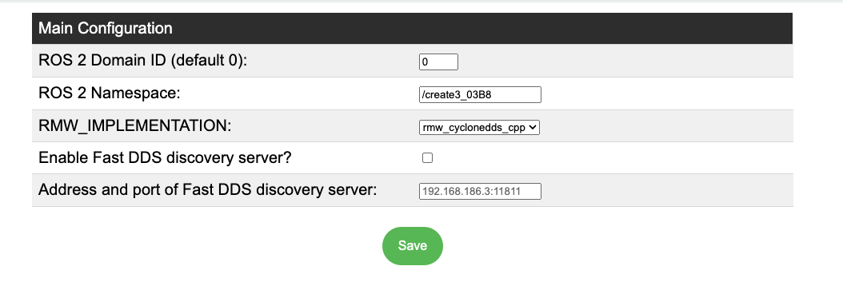
11. Under Application ROS 2 Parameters File
    1. Check the variable ‘reflexes_enabled’ is set to true
       1. If its not, just click on the box to edit it
    2. Hit the orange save button if you made any changes
    3. 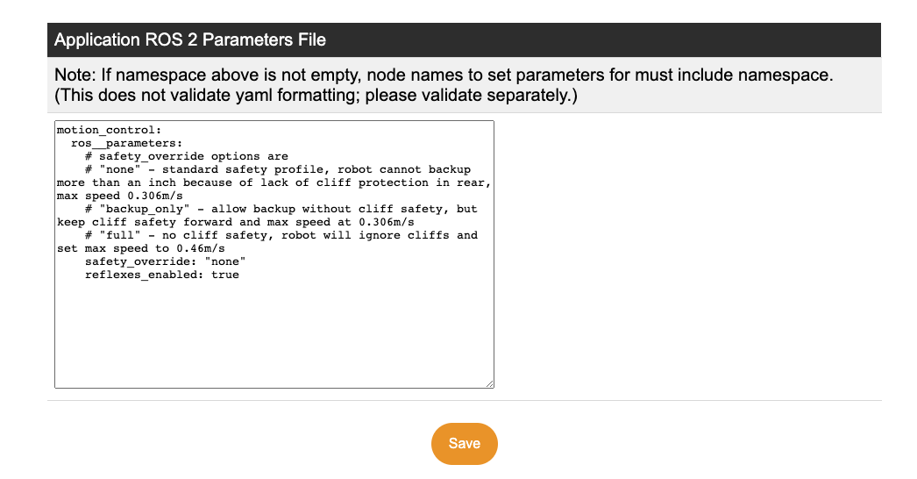
12. IF you made changes, click on the blue underlined ‘Restart application’ link and ‘Ok’ in the pop-up to restart the robot and wait for robot to chirp.
    1. If no changes were made, you can skip this step
13. Select the Connect tab
14. Under the ‘Connect to a 2.4 Wi-Fi Network’ select the first box.
    1. It should give you a list of networks it sees. You might need to click the rescan button if you don’t see your network
    2. 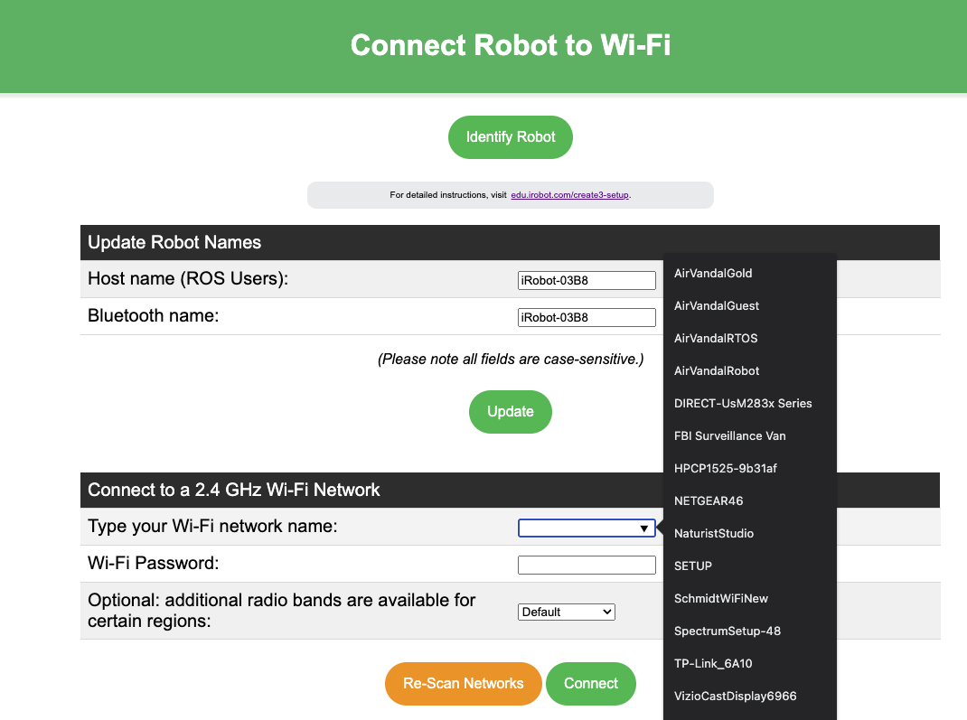
15. Put in your network credentials and hit ‘Connect’ (Not enter!)
    1. It should then make a couple of chirps signaling it successfully received the data
16. Wait until it plays a melody chirp and the LED ring is white

Your robot is all set up!

* You can verify its connected by using the command ‘ros2 topic list’ in Ubuntu. You should see a bunch of topics.
  + If you only see 2, either the robot isn’t connected or there is some other network issue. Reach out to Kris or Jacob for further assistance.